
DHARMSINH DESAI UNIVERSITY, NADIAD
FACULTY OF MANAGEMENT AND INFORMATION SCIENCE
B.C.A. SEMESTER VI
SUBJECT: (25BCA601)SYSTEM DEVELOPMENT PROJECT

Student Name | Himanshu D Ladha
Roll No | BCA045
Student ID | 23BCUOS055

Project Definition: RestoFlow is a full-stack Restaurant Management Platform built using .NET 10 Core and React JS, offering role-based access for Admins, Restaurant Owners, and Customers. It includes features like meal management, ordering, payments, and restaurant reviews to streamline restaurant operations and deliver a seamless digital dining experience.f

Company Timing: 11:00 AM to 6:00 PM

Week | Date | Day | Name of the Topic | Signature
Third Week | 15-12-2025 | Monday | Project Architecture and solution explorer
Third Week | 16-12-2025 | Tuesday | Authorization, Authentication and JWT tokens.
Third Week | 17-12-2025 | Wednesday | Perform the CRUD operations using the JWT tokens.
Third Week | 18-12-2025 | Thursday | Connection of Backend to Frontend
Third Week | 19-12-2025 | Friday | Managing the Restaurant Admin side

External Guide Name: Internal Guide Name: Prof. Rupal Patel
Signature Signature

15-12-2025
- Created the project structure in the backend side only.
- Project Api Architecture:-
  - Architecture Style: Clean / Layered Architecture
  - Project Type: ASP.NET Core Web API
  - ORM: Entity Framework Core\
  - Auth: JWT (Role-based)
- Solution Explorer:
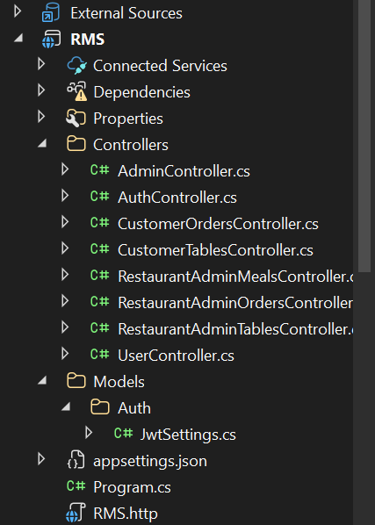 | 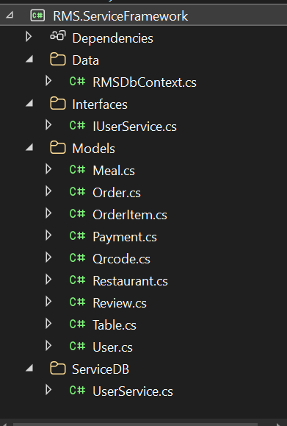

16-12-2025
- Learned about the Authorization and Authentication.
- JWT Tokens study and how to add this.
- Added the JWT bearer token in the API using the postman tool. And access the data by using the token, without this it cannot access.

17-12-2025
- Created the Bearer token in the remaining part.
- Add check the process of the token is proceed.
- Tested the token with all the CRUD operations.

18-12-2025
- Successfully connected the frontend and backend by configuring CORS and making HTTP requests using Axios.
- Implemented the complete API–Database communication flow:
Client (React / Postman)
↓ HTTP Request
Controller (API)
↓
Service Layer
↓
Entity Framework (DbContext)
↓
SQL Server (DB)
↑
Response (JSON)
- Developed Register and Login functionality with role-based access control, supporting:
  - Admin, Restaurant Admin, Customer
- Implemented Axios Interceptors to handle cross-cutting concerns such as:
  - Automatically attaching authentication tokens to API requests
  - Centralized login redirection
  - Request validation
This was done without modifying the core business logic, improving maintainability and code clarity.

19-12-2025
- I worked on the Restaurant side.
- At the time of registration of restaurant the functionality like basic details : name, address, opening time, closing time of the restaurant is added, so that registration of it can be done properly.
- Based on this login is performed.
- After that add the functionality of adding the table. Then, Based on that seating capacity, available status, and table no.
- In this particular button for the edit and delete is putted.
- Based on this backend changes are also made.
- This all things can be added for any particular restaurant.

